Neural Netwrok
Neural networks are a fundamental concept in machine learning and artificial intelligence, inspired by the structure of the human brain.

YOUTUBE PLAYLIST: Neural Netwrok Playlist

Key Components:
Input Layer: This is where the neural network receives the initial data. Each neuron in this layer represents a feature or input attribute.

Hidden Layers: These layers process the input data via mathematical operations, transforming it through weighted connections and applying activation functions. Deep neural networks have multiple hidden layers.

Output Layer: This layer produces the network's predictions or outputs based on the computations carried out by the hidden layers.

Weights and Biases: Neurons use weights and biases to modify the input data. Weights determine the strength of connections between neurons, and biases add an extra value to the output. During training, these weights and biases are adjusted to minimize the difference between the predicted output and the actual output.

Activation Functions: Each neuron applies an activation function, which introduces non-linearities into the network, allowing it to learn more complex relationships in the data. Common activation functions include ReLU (Rectified Linear Unit), Sigmoid, and Tanh.

Feedforward and Backpropagation: In feedforward, data passes through the network layer by layer, producing an output. Backpropagation is the method used to update the weights and biases of the network during training by calculating the gradient of the loss function with respect to the network's weights.

Loss Function: This function measures how well the network's predictions match the actual target values. The goal during training is to minimize this loss.

How Neurons Work:
Each neuron in a neural network takes in inputs, multiplies them by weights, adds a bias, and then passes this sum through an activation function. This activation function determines if and how the neuron should fire or be activated, generating the output to the next layer.

Neural Network Architecrures:
Neural networks have various architectures, such as convolutional neural networks (CNNs) for image data, recurrent neural networks (RNNs) for sequential data, and more complex architectures like deep neural networks (DNNs) or generative adversarial networks (GANs).

Keras:
Keras is high-level python deep learning API which is used for easy implementation of neural networks. It has multiple low-level backends like Tensorflow, Pytorch etc. which used for fast computation.

Gradient Descent:
- Gradient descent is an optimization algorithm commonly used in machine learning and deep learning for minimizing the cost function.
- The cost function represents the difference between the predicted values of the model and the actual values (labels) in the training data.
- The goal of gradient descent is to find the set of parameters (weights and biases) that minimizes this cost function.

Here's a high-level overview of how gradient descent works:

- Initialize Parameters: Start with initial values for the model parameters (weights and biases).

- Forward Propagation: Use the current parameters to make predictions on the training data.

- Compute Cost: Calculate the cost or error between the predicted values and the actual values using the chosen cost function.

- Backward Propagation (Gradient Calculation): Calculate the gradient of the cost function with respect to each parameter. This involves computing the partial derivatives of the cost function with respect to each parameter.

- Update Parameters: Adjust the parameters in the opposite direction of the gradient. This is done to move towards the minimum of the cost function.

- Repeat: Repeat steps 2-5 until the cost converges to a minimum or a predetermined number of iterations is reached.

Types of Gradient Descent:
Batch Gradient Descent: Computes the gradient of the cost function using the entire training dataset.

Stochastic Gradient Descent (SGD): Updates the parameters after each training example.

Activation Functions:
An activation function is a mathematical operation applied to the output of a neuron in a neural network. It introduces non-linearity to the model, enabling it to learn complex patterns in data. Without activation functions, a neural network would be equivalent to a linear regression model, and it would not be able to capture the non-linear relationships present in many real-world datasets.

Properties:
Non-Linearity:
Introducing non-linearity allows neural networks to learn complex, non-linear relationships within the data. Without non-linear activation functions, the entire network would collapse into a linear model, limiting its capacity to capture intricate patterns in data.

Differentiability:
Differentiability is crucial for training neural networks using optimization algorithms like gradient descent. Backpropagation, the algorithm commonly used for training, relies on the calculation of gradients to update the model parameters. If an activation function is not differentiable, it becomes challenging to compute these gradients, hindering the training process.

Zero-Centered:
A zero-centered activation function helps in weight initialization and optimization. When the activation values are centered around zero, it can make it easier for the optimization algorithm to converge during training. This is particularly relevant for symmetric activation functions like tanh, which naturally centers around zero.

Non-Saturation:
Saturation refers to the flat regions of an activation function where the gradient becomes very small. In these regions, the network has difficulty learning because the updates to the weights during training are minimal. Non-saturated activation functions, especially in the positive direction, help mitigate the vanishing gradient problem, allowing for more effective learning, particularly in deep networks.

Types of activation functions:
Sigmoid:
The sigmoid activation function, also known as the logistic function, is a popular activation function used in neural networks.

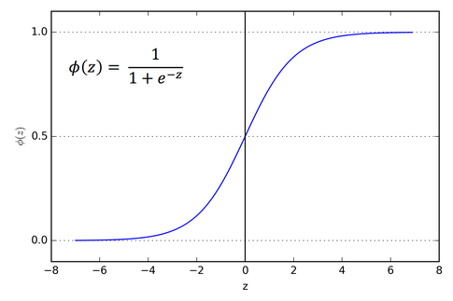

In formula, e is the base of the natural logarithm (approximately 2.71828), and
z is the input to the function.

However, the sigmoid activation function has some limitations:

Vanishing Gradient:
In deep neural networks, the sigmoid function can suffer from the vanishing gradient problem. As the input moves toward extreme values (very large or very small), the gradient becomes close to zero, leading to slow or halted learning in deep networks.

Not Zero-Centered:
The sigmoid function is not zero-centered, which may result in challenges during optimization. Weight updates can lead to shifts in the weight space that may not be ideal for convergence.

tanh:
The hyperbolic tangent (tanh) activation function is another commonly used activation function in neural networks. It is a mathematically shaped curve that squashes input values to the range of (−1,1).

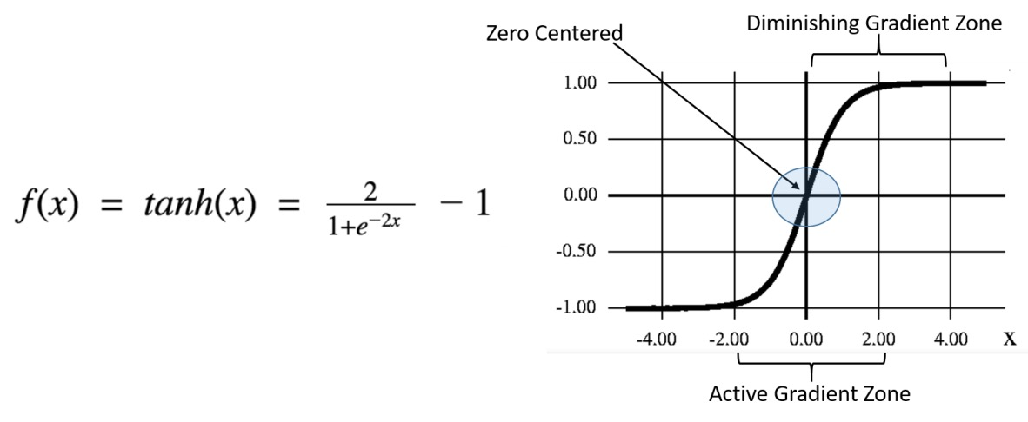
Key properties and characteristics of the tanh activation function include:

Output Range:
The tanh function outputs values in the range of (−1,1), making it zero-centered. This characteristic can be beneficial for optimization algorithms, especially in the context of training deep neural networks.

Zero-Centered:
Unlike the sigmoid function, tanh is zero-centered, which means that the average of its outputs is zero. This can help mitigate issues related to weight updates during training and can be advantageous for optimization.

Differentiability:
The tanh function is differentiable everywhere, making it suitable for gradient-based optimization algorithms like backpropagation.

Despite its advantages, the tanh activation function shares some challenges with the sigmoid function, such as the vanishing gradient problem. In deep neural networks, especially those with many layers, the gradients can become very small as the input values move toward the extremes, leading to slow or stalled learning.

While tanh is used in certain scenarios, rectified linear unit (ReLU) and its variants are often preferred for hidden layers in deep neural networks due to their simplicity and ability to address the vanishing gradient problem more effectively. Tanh is still sometimes used in situations where zero-centered activation is deemed beneficial

ReLU:
ReLU, which stands for Rectified Linear Unit, is an activation function commonly used in neural networks, especially for the hidden layers.

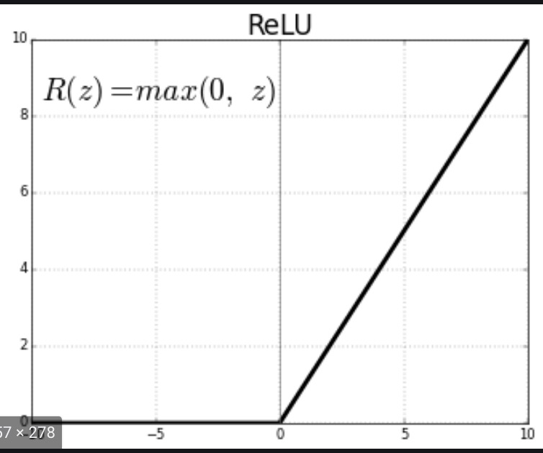
Key properties and characteristics of the ReLU activation function include:

Non-Linearity:
ReLU introduces non-linearity to the network, enabling it to learn and represent complex, non-linear relationships in data.

Sparsity:
ReLU can lead to sparsity in the network. As any negative input is mapped to zero, some neurons become inactive, promoting a sparse representation. This can be advantageous for memory efficiency and computational speed.

Computational Efficiency:
ReLU is computationally efficient to compute, as it involves a simple thresholding operation. This contributes to faster training times compared to some other activation functions.

Avoiding Vanishing Gradient:
ReLU helps mitigate the vanishing gradient problem, which can occur with activation functions like sigmoid and tanh. The gradient is non-zero for positive inputs, allowing for more effective weight updates during backpropagation.

While ReLU is widely used, it does have some potential drawbacks:

Dead Neurons:
Neurons that become inactive (always output zero) during training are often referred to as "dead neurons." This can happen if the input to a ReLU neuron is consistently negative. In such cases, the neuron does not contribute to the learning process.

Not Zero-Centered:
ReLU is not zero-centered, which might lead to issues in certain scenarios. The lack of a negative output may result in weights that update in a way that is not optimal for convergence.

Leaky Relu:
Leaky ReLU (Rectified Linear Unit) is an activation function that addresses one of the drawbacks of the traditional ReLU function, namely the issue of "dead neurons." In standard ReLU, if the input is negative, the output is zero, and the neuron becomes inactive, potentially causing issues during training. Leaky ReLU introduces a small, non-zero slope for negative inputs, allowing some information to flow even when the input is negative.

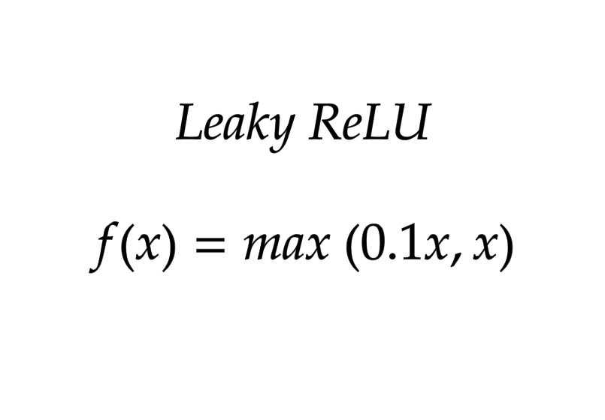

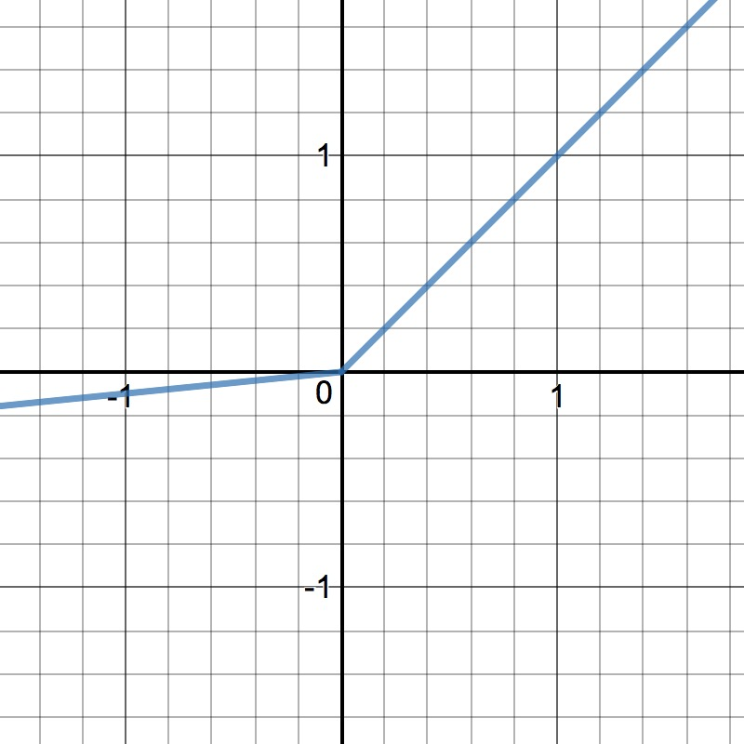

Softmax:
The softmax activation function is commonly used in the output layer of a neural network for multi-class classification problems. It converts a vector of real numbers into a probability distribution. The output values produced by the softmax function can be interpreted as probabilities, and they sum to 1.

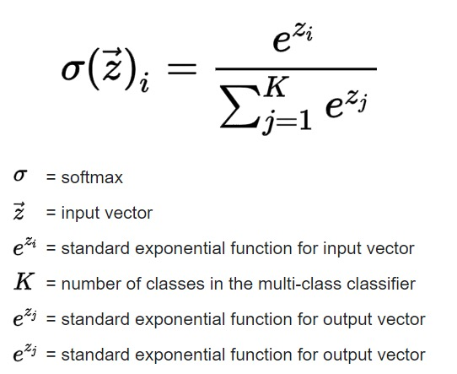

Loss Function:
In neural networks, loss functions play a crucial role in training the model by quantifying the difference between the predicted output and the actual target values.

Here are some common loss functions and their purposes:

Mean Squared Error (MSE):

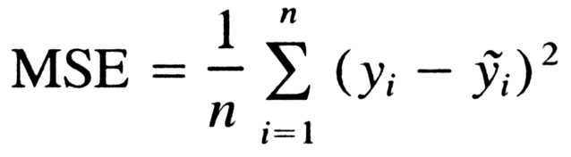

Purpose:
MSE is used as a loss function in regression problems, where the goal is to predict a continuous numeric value.

Calculation:
For each data point, it calculates the squared difference between the predicted value and the actual value.
The squared differences are averaged over all data points to obtain the mean.

Characteristics:
Squaring the differences gives more weight to larger errors. This makes MSE sensitive to outliers.
It provides a measure of the average "spread" of errors.

Mean Absolute Error:
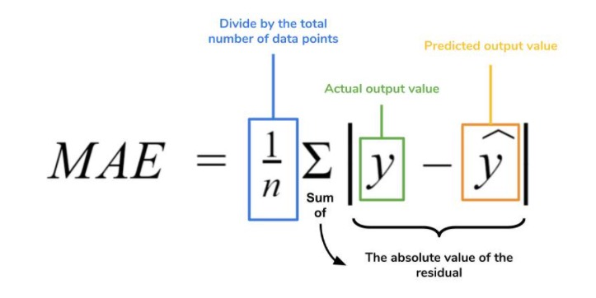

Purpose:
MAE is used as a loss function in regression problems, where the goal is to predict a continuous numeric value.

Calculation:
For each data point, it calculates the absolute difference between the predicted value and the actual value.
The absolute differences are averaged over all data points to obtain the mean.

Characteristics:
MAE provides a linear measure of error, giving equal weight to all errors regardless of their magnitude.
It is less sensitive to outliers compared to Mean Squared Error (MSE) because it does not involve squaring the differences.

Binary Cross-Entropy Loss:
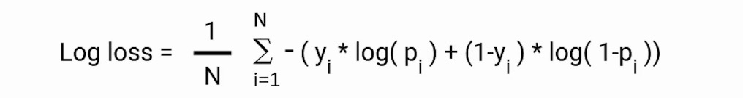

Purpose:
Binary Cross-Entropy Loss is specifically designed for binary classification problems, where each instance belongs to one of two classes.

Calculation:
For each data point, it calculates the cross-entropy loss between the predicted probability and the actual class label.
The cross-entropy losses are averaged over all data points to obtain the mean loss.

Characteristics:
The logarithmic nature of the loss function penalizes confidently incorrect predictions more heavily.
The loss is minimized when the predicted probabilities match the true class labels.

Categorical Cross-Entropy Loss:
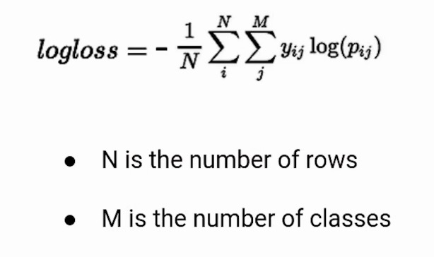

Purpose:
Categorical Cross-Entropy Loss is specifically designed for multi-class classification problems, where each instance belongs to one of several classes.

Calculation:
For each data point, it calculates the cross-entropy loss between the predicted class probabilities and the true class labels.
The cross-entropy losses are averaged over all data points to obtain the mean loss.

Characteristics:
The loss is minimized when the predicted probabilities align with the true class labels for each instance.
It penalizes confidently incorrect predictions more heavily, similar to Binary Cross-Entropy Loss.

Sparse Categorical Cross-Entropy Loss:

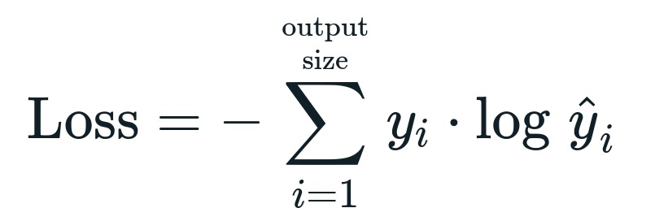

Purpose:
Sparse Categorical Cross-Entropy Loss is specifically designed for multi-class classification problems where class labels are provided as integers (not one-hot encoded vectors).

Calculation:
For each data point, it calculates the cross-entropy loss between the predicted class probabilities and the true class label (provided as an integer).
The cross-entropy losses are averaged over all data points to obtain the mean loss.

Characteristics:
It is computationally more efficient than Categorical Cross-Entropy Loss when dealing with a large number of classes.
It handles scenarios where most class labels are 0 (indicating a class absence) efficiently.

CNN ANIMATION URL: https://animatedai.github.io/
Convolutional Neural Network (CNN):
A Convolutional Neural Network (CNN) is a type of neural network architecture designed for processing grid-like data, such as images.

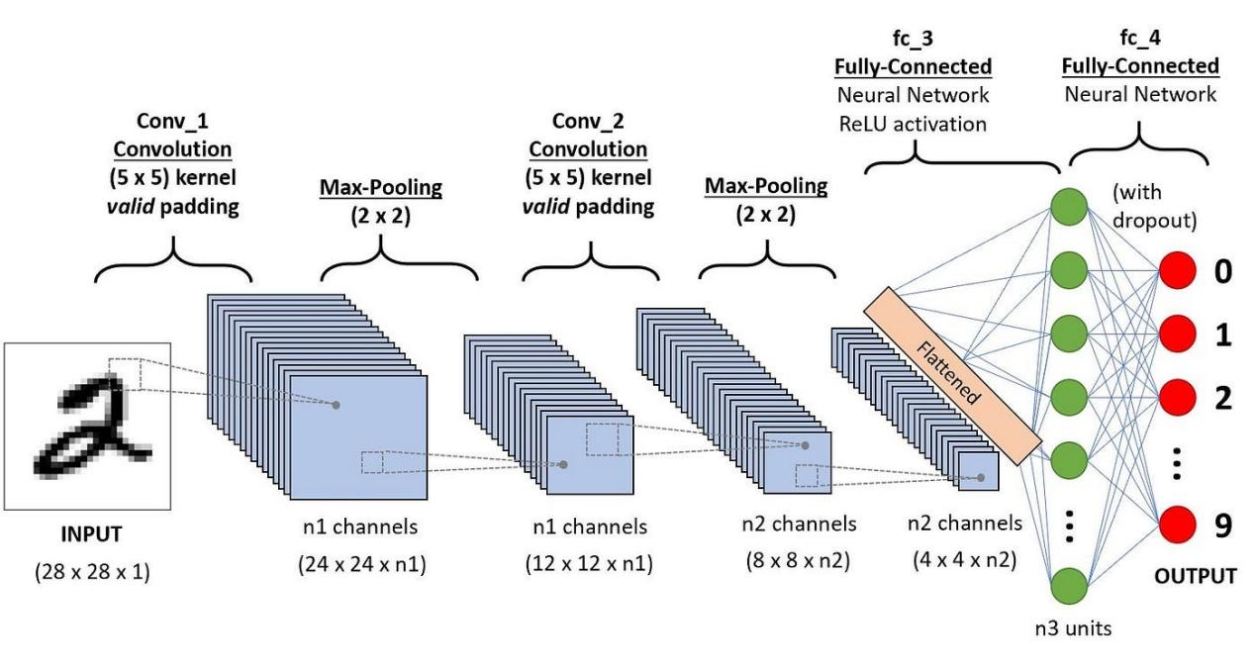

Valid vs Same convolution:

Valid Convolution:
In a "valid" convolution (also known as "no padding"), the convolution operation is performed in such a way that the filter/kernel is only applied to the input volume where the filter and the input fully overlap.

Advantages of "Valid" Convolution:
- Dimension Reduction: "Valid" convolutions reduce the spatial dimensions of the feature maps. This reduction can be advantageous in certain scenarios where downsampling is necessary to decrease computational complexity or to extract higher-level abstract features from the input.

- Less Computational Cost: Valid convolutions typically involve fewer computations compared to "same" convolutions since they generate smaller output feature maps by not padding the input. This can lead to faster training and inference times, which is beneficial when computational resources are limited.

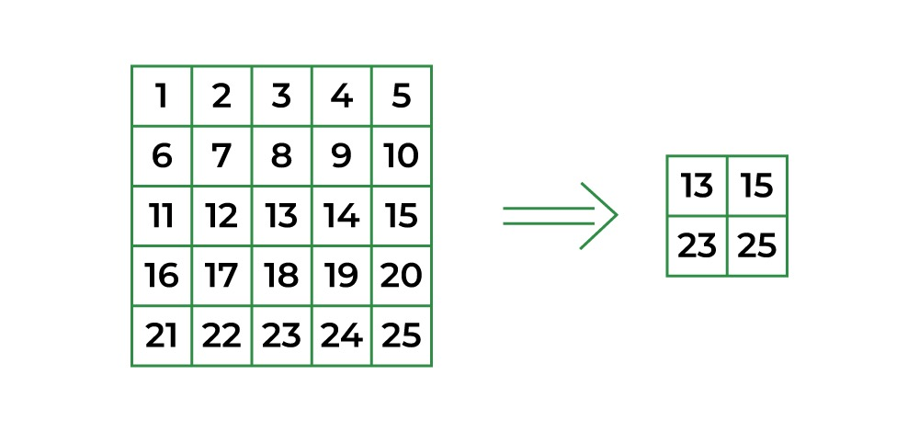

Same Convolution:
In contrast, "same" convolution is a type of convolution where the output feature map has the same spatial dimensions (width and height) as the input volume. To achieve this, padding is added to the input volume, usually in the form of zero-padding, so that the filter can be centered at every position in the input volume.

Advantages of "Same" Convolution:
- Preservation of Spatial Information: The primary advantage of "same" convolutions is that they preserve the spatial dimensions of the input feature maps. This is crucial in certain architectures where maintaining the spatial context and resolution of the input is important for accurate feature extraction.

- Edge Information Retention: Padding in "same" convolutions ensures that the edges of the input are more thoroughly processed since the filters can cover the edges multiple times. This helps in retaining edge information, which might be critical in tasks such as image segmentation or boundary detection.
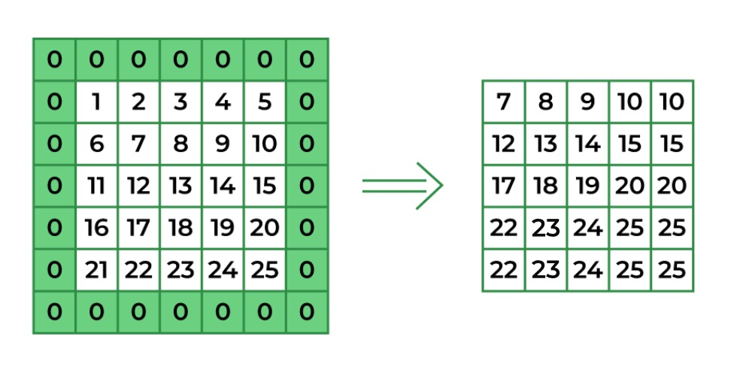

Strided convolution:
Strided convolution is a technique used in Convolutional Neural Networks (CNNs) that involves applying convolutional filters to an input with a certain stride value.

Advantages and Use Cases:
Downsampling: Strided convolutions are often used to downsample feature maps, reducing the computational load in deeper layers of the network. This downsampling helps in extracting high-level features from a larger receptive field while reducing the number of computations.

Dimension Reduction: They enable the network to learn hierarchical representations by progressively reducing the spatial dimensions, allowing the network to capture larger receptive fields and abstract features in deeper layers.

Computational Efficiency: Strided convolutions reduce the number of operations and memory requirements compared to standard convolutions by skipping certain computations, making the network more computationally efficient.

Considerations:
Information Loss: Strided convolutions reduce the spatial dimensions, potentially causing information loss, especially fine-grained details in the input. This might impact tasks where precise spatial information is critical.

Stride Size and Architecture: The choice of stride size influences the amount of downsampling and, subsequently, the network's receptive field. It's often combined with other techniques (like pooling) and tailored to the specific architecture or task requirements.
CNN Working:
Input Layer:
- The input layer receives the raw input data, which is typically an image in the case of computer vision applications.
- The input data is represented as a three-dimensional array (height x width x channels), where channels correspond to color channels (e.g., red, green, blue for a color image).

Convolutional Layers:
- Convolutional layers are the core building blocks of a CNN.
- Each convolutional layer applies convolutional operations to the input data using learnable filters or kernels.
- These filters slide over the input data, capturing local patterns and creating feature maps.
- Multiple filters in each layer help the network learn different features.

Activation Function (e.g., ReLU):
- After the convolutional operation, an activation function like Rectified Linear Unit (ReLU) is commonly applied element-wise to introduce non-linearity.

Pooling Layers:
- Pooling layers downsample the spatial dimensions of the feature maps, reducing computational complexity and the risk of overfitting.
- Max pooling is a common technique, where the maximum value in each local region is retained.

Flatten Layer:
- After several convolutional and pooling layers, a Flatten layer is typically used to convert the two-dimensional output into a one-dimensional vector.
- This prepares the data for feeding into fully connected layers.

Fully Connected Layers:
- These layers connect every neuron to every neuron in the previous and next layers.
- Fully connected layers process the flattened vector and learn global patterns and relationships in the data.
- They are often followed by activation functions.

Output Layer:
- The output layer produces the final predictions.
- The number of neurons in this layer depends on the task (e.g., binary classification, multi-class classification, regression).
- Activation functions like softmax (for classification) or linear (for regression) are applied.

Loss Function:
- The choice of the loss function depends on the task. For example, categorical cross-entropy is common for classification tasks, while mean squared error may be used for regression.

Optimizer:
- Optimizers, such as Adam or Stochastic Gradient Descent (SGD), are used to minimize the loss function and update the model's weights during training.

Training:
- The CNN is trained using labeled data (input-output pairs) through a process of forward and backward propagation.
- Backpropagation adjusts the weights of the network to minimize the difference between predicted and actual outputs.

Regularization Techniques:
- Techniques like dropout or batch normalization may be used to prevent overfitting and improve generalization.

Spatial Information:
In the context of computer vision and image processing, spatial information often refers to the arrangement of pixels in an image and the relationships between them.
Example:
- In a dog image, spatial information would include details about the arrangement of pixels to form features such as the dog's body, head, tail, and limbs.
- The spatial information might describe the relative positions of the dog's ears, eyes, nose, and other distinctive features.
- It could also encompass the overall shape and size of the dog within the image.

Image augmentation:
Image augmentation is a technique used to artificially increase the diversity of a training dataset by applying various transformations to the existing images. This helps improve the generalization and robustness of machine learning models, especially in computer vision tasks. Common transformations include rotation, scaling, flipping, and changes in brightness and contrast. In Keras, the ImageDataGenerator class is often used to perform image augmentation.

CNN Pretrained Model:
What is ImageNet?
ImageNet is formally a project aimed at (manually) labeling and categorizing images into almost 22,000 separate object categories for the purpose of computer vision research.

Lenet-5:

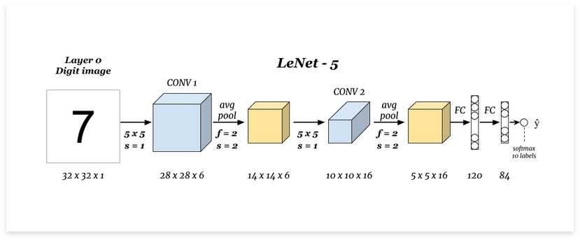

Parameters: 60k
Activation functions: Sigmoid/tanh

Input Layer:
The network begins with the input layer, which takes in the grayscale images of handwritten digits. The typical input size for LeNet-5 is 32x32 pixels.

Convolutional Layer (C1):
In this layer, convolutional operations are applied to the input image using a set of learnable filters or kernels. These filters help extract low-level features, such as edges and basic textures.

Subsampling Layer (S2):
Following the convolutional layer, a subsampling layer (often implemented as average pooling) is employed. Average pooling computes the average value of a set of pixels within a specified region, providing a smoother downsampling compared to max pooling. This helps reduce the spatial dimensions of the convolved features while retaining essential information, making the network more robust to variations in the input.

Convolutional Layer (C3):
Another convolutional layer is applied to the subsampled output from S2. This layer extracts higher-level features from the input data, combining the low-level features obtained in C1.

Subsampling Layer (S4):
Similar to S2, this layer performs average pooling to further reduce the spatial dimensions of the convolved features.

Fully Connected Layer (C5):
The subsampled output is flattened and connected to a fully connected layer. This layer is designed to capture complex relationships in the data by connecting every neuron to every neuron in the previous and subsequent layers.

Output Layer (Output):
The final fully connected layer produces the output, representing the class scores for each digit. Typically, softmax activation is applied to obtain probabilities for each class, and the class with the highest probability is considered the predicted class.

LeNet-5 was groundbreaking for its time, showcasing the effectiveness of convolutional neural networks in recognizing handwritten digits. While modern architectures have evolved and become more complex, LeNet-5's principles are foundational in the development of contemporary CNNs, especially in computer vision and image recognition tasks.

Alexnet:

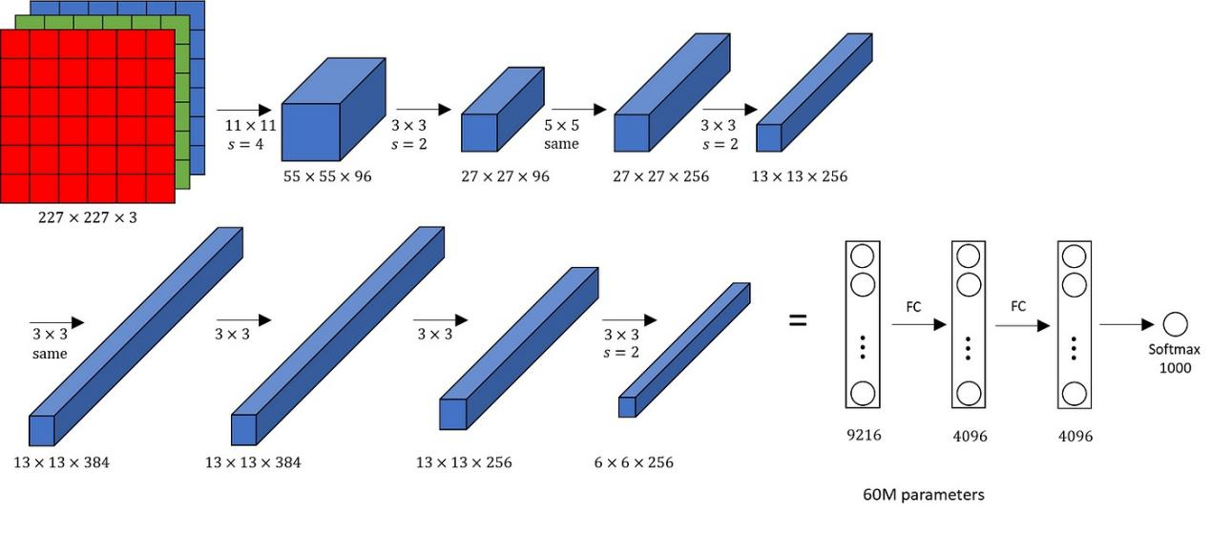

Parameters: 60M
Activation functions: Relu

AlexNet is a deep convolutional neural network architecture that played a pivotal role in the field of computer vision and image classification. It was developed by Alex Krizhevsky, Ilya Sutskever, and Geoffrey Hinton, and it won the ImageNet Large Scale Visual Recognition Challenge (ILSVRC) in 2012, marking a significant advancement in deep learning. Here's an overview of the AlexNet architecture:

Input Layer:

Accepts the input image data. In the case of the ImageNet dataset, the typical input size is 224x224 pixels.

Convolutional Layers (C1-C5):
AlexNet consists of five convolutional layers. These layers employ filters of various sizes to extract features from the input image. Rectified Linear Unit (ReLU) activation functions are applied after each convolutional operation.

Max-Pooling Layers (P1-P3):
Three max-pooling layers are interspersed between the convolutional layers (C1-C5). Max-pooling reduces the spatial dimensions of the feature maps, enhancing translation invariance and computational efficiency.

Normalization Layer (N1-N2):
Local Response Normalization (LRN) is applied after the first and second convolutional layers to enhance the model's generalization ability.

Fully Connected Layers (FC6-FC8):
Three fully connected layers follow the convolutional and pooling layers. These layers capture high-level features and spatial hierarchies. Dropout is applied to reduce overfitting.

Output Layer (Output):
The final layer produces the output, representing class scores for the input image. The softmax activation function is typically used to convert the scores into probabilities.

VGG:
VGG, or Visual Geometry Group, is a convolutional neural network (CNN) architecture that has been widely used in computer vision tasks, particularly image classification. It was introduced by the Visual Geometry Group at the University of Oxford.

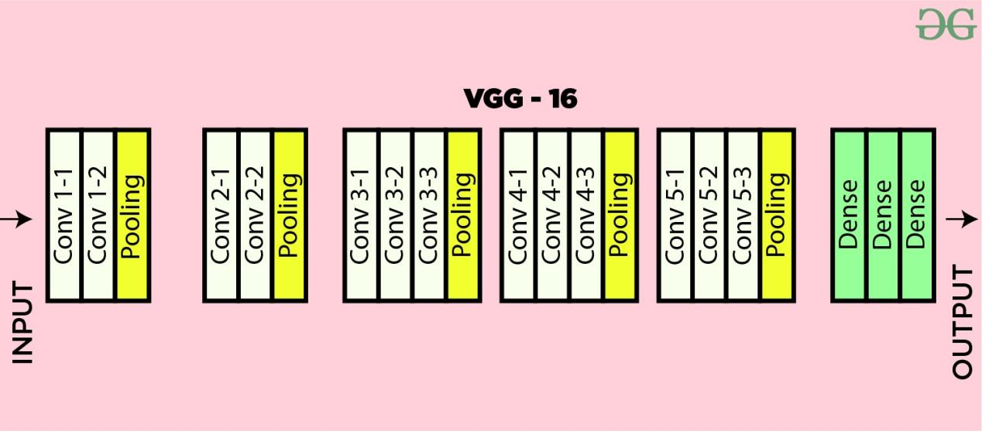

Key characteristics of the VGG architecture include:

- Uniform Architecture:
VGG networks have a simple and uniform architecture. The convolutional part of the network consists of several blocks, each containing multiple convolutional layers followed by max-pooling layers.

- Small Convolutional Filters:
VGG networks use small 3x3 convolutional filters throughout the architecture. The use of these small filters allows the network to learn more complex features while keeping the number of parameters relatively low.

- Deep Networks:
VGG networks can be deep, with 16 or 19 weight layers. The depth of the network contributes to its ability to learn hierarchical features.

- Pooling Layers:
Max-pooling layers are used to reduce the spatial dimensions of the feature maps, capturing the most important information while discarding less relevant details.

- Fully Connected Layers:
The convolutional layers are followed by one or more fully connected layers, which are responsible for making predictions based on the features learned by the convolutional layers.

ResNet (Residual Network):
ResNet, short for Residual Network, is a type of convolutional neural network (CNN) architecture designed to address the challenges of training very deep neural networks.

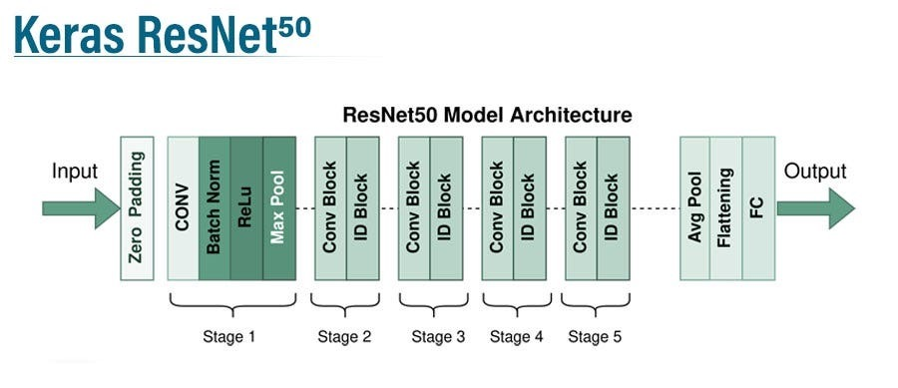

Key features of the ResNet architecture include:

- Residual Blocks:
The fundamental building block of ResNet is the residual block. It introduces a shortcut connection, also known as a skip connection or identity shortcut, which skips one or more layers. The idea is to allow the network to learn residual functions, making it easier to train very deep networks.

- Deep Architectures:
ResNet architectures can be very deep, with hundreds of layers. Prior to ResNet, training such deep networks was challenging due to issues like vanishing gradients. The introduction of residual connections mitigates these problems, enabling the successful training of extremely deep networks.

- Identity Mapping:
The residual block's skip connection performs identity mapping when no transformation is required. This means that the input to the block is directly added to the output. This helps in preserving useful information throughout the network.

- Batch Normalization:
Batch normalization is often used in conjunction with residual blocks to stabilize and accelerate training. It normalizes the input to a layer, reducing internal covariate shift and improving the overall training process.

- Global Average Pooling:
ResNet typically uses global average pooling instead of fully connected layers at the end of the network. This helps reduce the number of parameters and makes the model more robust to spatial translations of the input.

Inception:
The Inception architecture, also known as GoogLeNet, was introduced by Google researchers in 2014 and won the ImageNet Large Scale Visual Recognition Challenge (ILSVRC) that year. It's renowned for its efficient use of computational resources and deep learning capabilities.

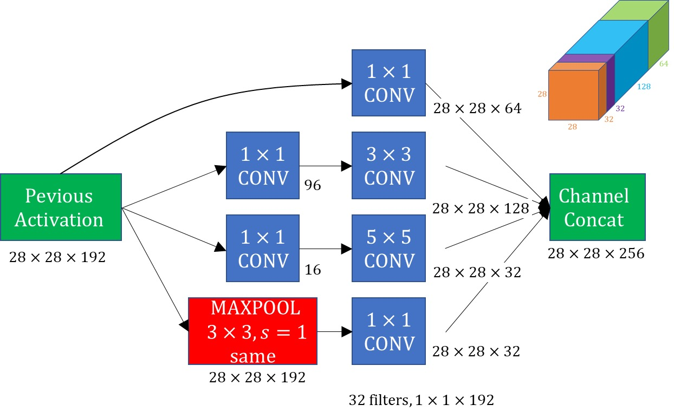

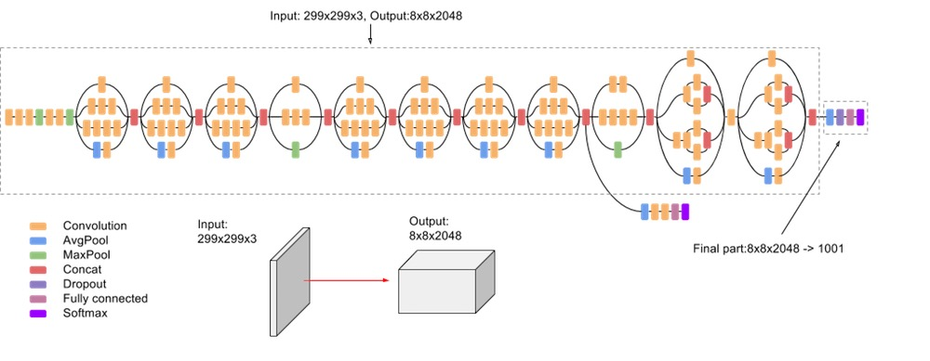

Here are some key details about the Inception architecture:

Inception Modules:
One of the distinctive features of Inception is the use of inception modules. These modules consist of multiple convolutional filters of different sizes (1x1, 3x3, 5x5) and pooling operations. The outputs of these operations are then concatenated to form the module's output.
1x1 Convolutions:
Inception makes extensive use of 1x1 convolutions to reduce the dimensionality of the input channels. These are used for dimensionality reduction before applying larger convolutional filters.

Auxiliary Classifiers:
Inception includes auxiliary classifiers at intermediate layers during training. These auxiliary classifiers are used to mitigate the vanishing gradient problem and provide additional supervision during training.

Global Average Pooling:
Instead of using fully connected layers at the end of the network, Inception utilizes global average pooling. This helps reduce the number of parameters and prevents overfitting.

Efficient Use of Parameters:
Despite its depth, Inception manages to use parameters efficiently, making it computationally more efficient compared to other deep networks.

Batch Normalization:
Inception incorporates batch normalization, which helps in stabilizing and accelerating the training process by normalizing the inputs to each layer.

Successive Versions:
Inception has gone through several versions, with each iteration aiming to improve performance and efficiency. Inception V1 was the original model, and subsequent versions such as V2 and V3 have been introduced with enhancements.

Applications:
Inception and its variations have been used in various computer vision tasks, including image classification, object detection, and segmentation.

Recurrent Neural Network:
It is a type of artificial neural network designed to process sequential data by retaining information in memory over time. Unlike feedforward neural networks, which have a single direction of data flow, RNNs have connections that loop back on themselves, allowing them to maintain a memory of previous inputs. This makes them particularly effective for tasks involving sequential data, such as time series prediction, natural language processing (NLP), speech recognition, and handwriting recognition.

Here's an example of how an RNN works: Imagine you're training a model to generate text. At each time step, the RNN takes in a single word or character as input and updates its internal state based on both the current input and the previous state. This allows the RNN to capture dependencies and patterns in the sequence of words or characters, enabling it to generate coherent text.

One common issue with traditional RNNs is the vanishing gradient problem, where gradients diminish as they propagate through many time steps, making it difficult for the network to learn long-term dependencies. To address this issue, various types of RNNs have been developed, such as Long Short-Term Memory (LSTM) networks and Gated Recurrent Units (GRUs), which are better at capturing long-range dependencies by incorporating mechanisms to selectively retain or forget information.

Overall, RNNs have been instrumental in advancing the fields of machine learning and natural language processing, enabling models to effectively process and generate sequential data.

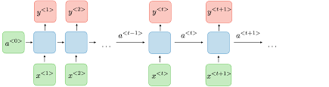

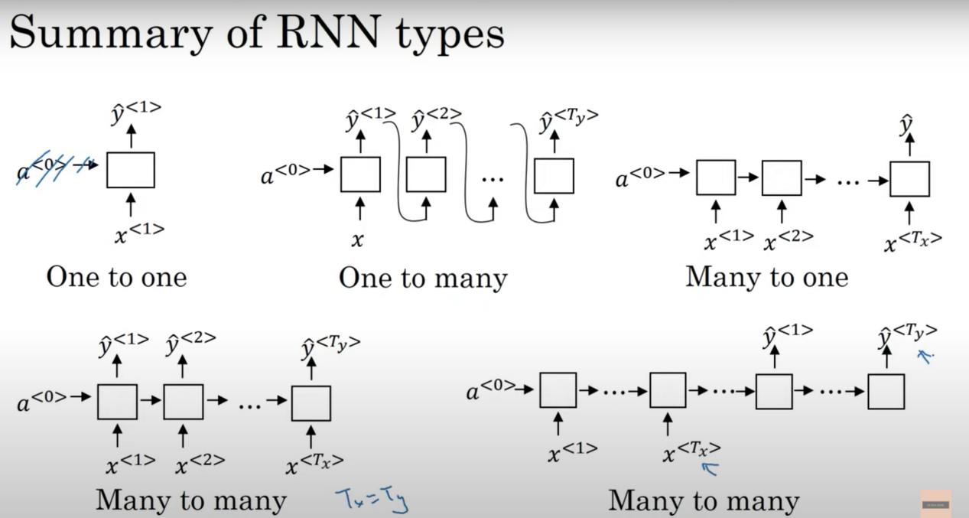

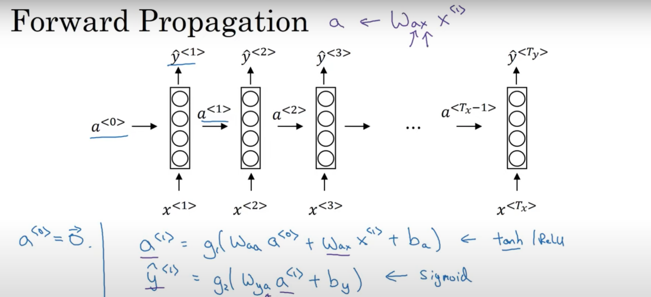

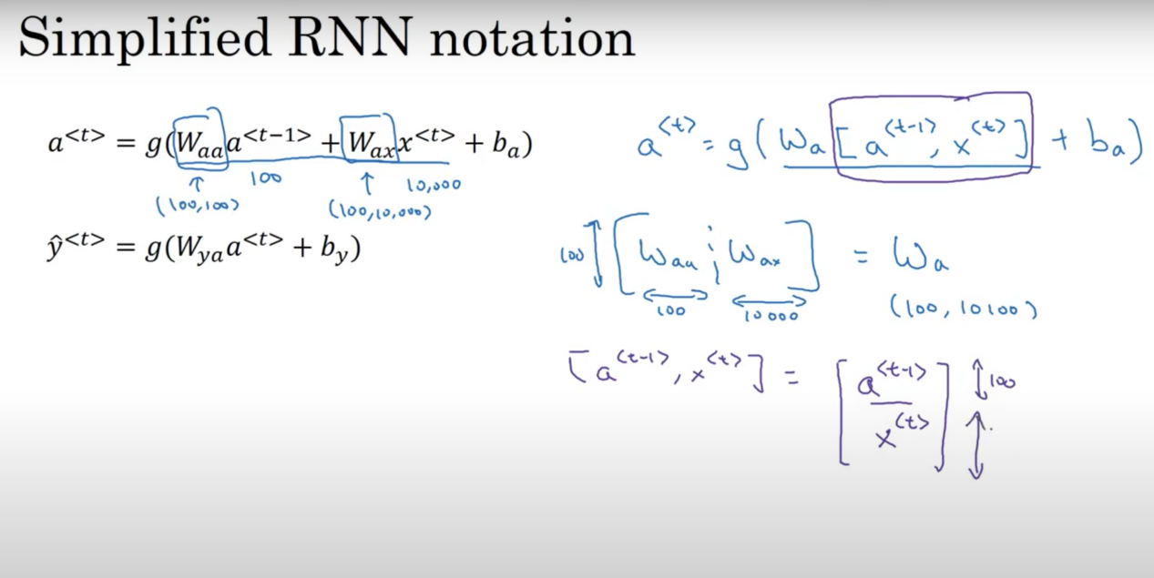

Word Embbdings:
- Computer understands only numbers.
- Word Embeddings are the texts converted into numbers
- A vector representation of a word may be a one-hot encoded vector like [0,0,0,1,0,0].
- It is capable of capturing context of a word in a document, semantic and syntactic similarity, relation with other words, etc
- A word embedding is a learned representation for text where words that have the same meaning have a similar representation.

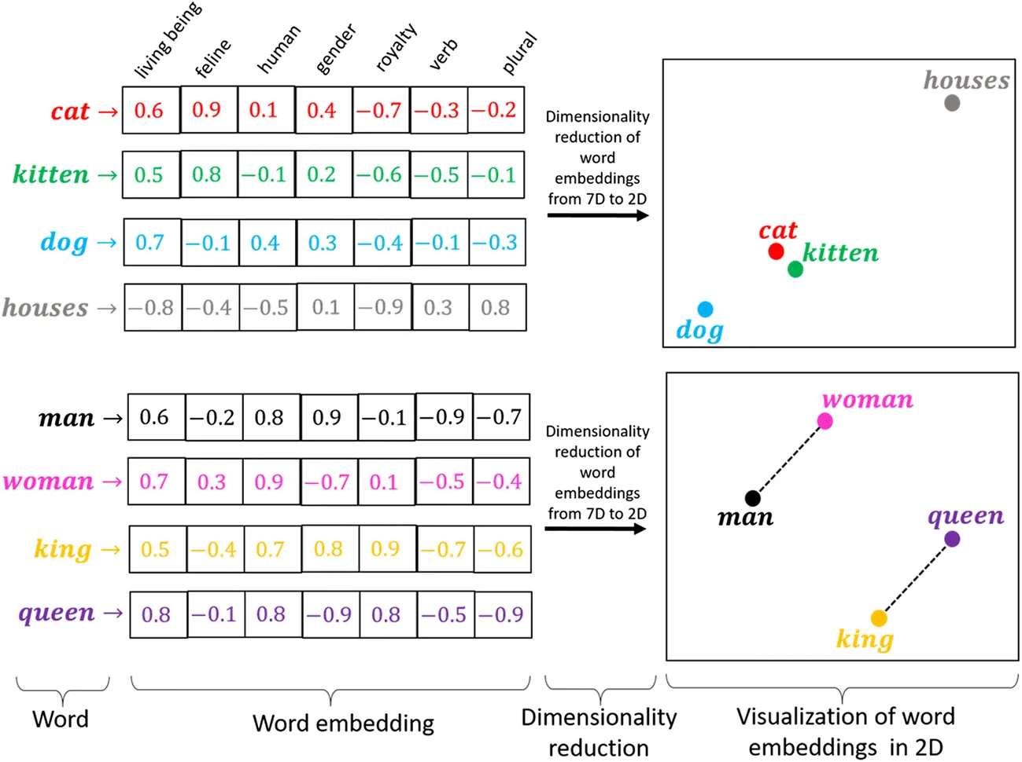

Frequency based Embedding:
- Count Vectors:
Count Vector is based on the frequency of each word.

Example:
Lets assume that our corpus has 2 documents:
Document1 = ‘He is a lazy boy. She is also lazy.’
Document2 = ‘Neeraj is a lazy person.’

Create Dictionary of the corpus (unique word in the corpus):
[‘He’,’She’,’lazy’,’boy’,’Neeraj’,’person’]

Here number of unique word(corpus length) is 6.

Create a count matrix:

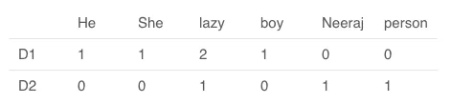

Now, a column can be understood as word vector for the corresponding word.
Example: ‘He’ has count vector [1,0]
word ‘lazy’ has count vector [2,1]
word ‘person’ has count vector [0,1]

- TF-IDF:
- The limitation of count vector is that common words appears frequently and frequency of important word is very less.
- term frequency-inverse document frequency(tf-idf) gives the weightage to that word which occurs very less time. i.e, it captures the uniqueness.
- TF = (Number of times term t appears in a document)/(Number of terms in the document)
- IDF = log(N/n), where, N is the total number of documents and n is the number of documents a term t has appeared in.

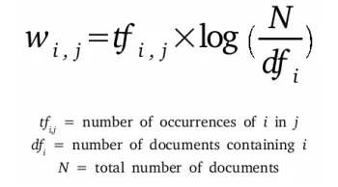

Example:
Lets take 2 documents as:
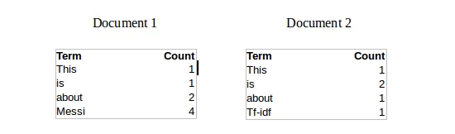

- term frequency(TF) of word “This” in Document 1 is 1/8 and TF of word “This” in Document 2 is 1/5
- IDF(This) = log(2/2) = 0
- If a word appears in each document of given corpus then idf of that word = 0
- IDF(Messi) = log(2/1) = 0.301.
- Combine TF and IDF together:
- TF-IDF(This,Document1) = (1/8) * (0) = 0
- TF-IDF(This, Document2) = (1/5) * (0) = 0
- TF-IDF(Messi, Document1) = (4/8)*0.301 = 0.15

Probelm with tf-idf:
- tf-idf is the multiplication of tf and idf, if tf value is very high then tf-idf value will be more.
- To avoid this we use logarithmic method called BM25.

- Co-Occurrence Matrix:
How two or more words occur together in a given corpus.

Exmple:
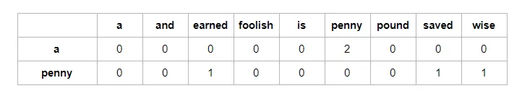

The above table shows that “a” is followed twice by “penny” while words “earned”, “saved”, and “wise” each follows “penny” once in our corpus. Thus, “earned” is one out of three times probable to appear after “penny.

Analogies reasoning of embedding:
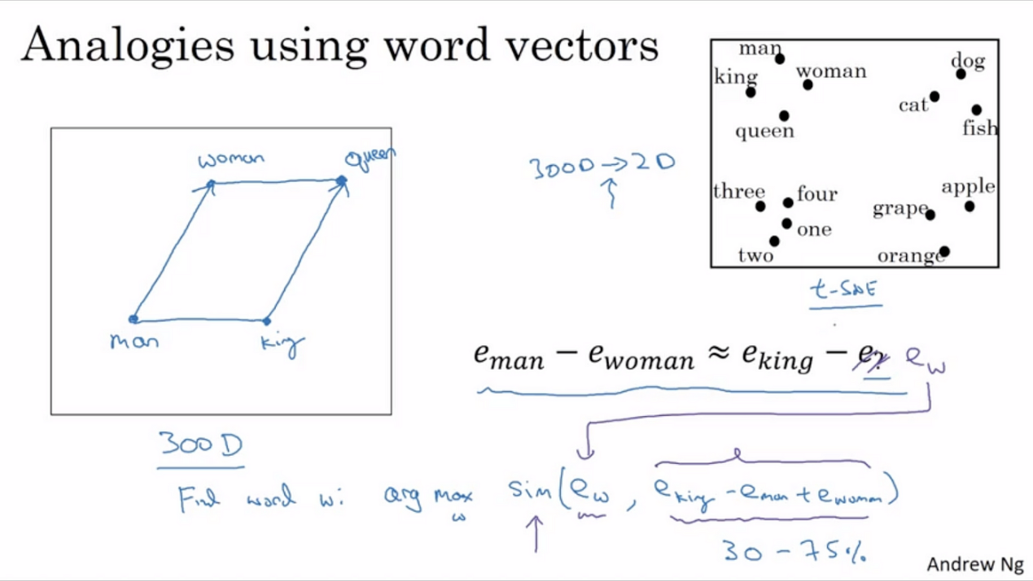

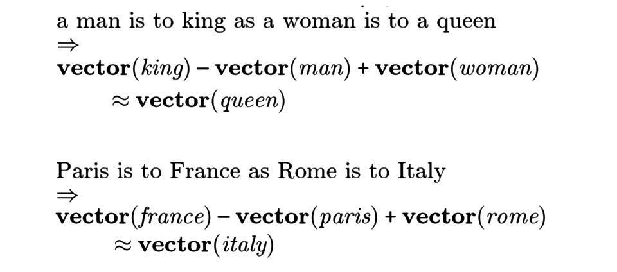

These embeddings capture semantic relationships between words, allowing for algebraic operations on word vectors to find analogies. The classic example is the analogy "king is to queen as man is to woman."

Prediction based methods:

Embedding Matrix:
In the context of NLP, an embedding matrix is essentially a lookup table that maps discrete tokens (such as words or subwords) to their corresponding dense vector representations (embeddings). Here's how it works:

Initialization: Initially, the embedding matrix is randomly initialized with small values.

Lookup Operation: During the forward pass of the neural network, the input tokens (usually represented as one-hot vectors or integer indices) are used to index into the embedding matrix. This operation efficiently retrieves the dense embeddings corresponding to the input tokens.

Training: During training, the embeddings in the matrix are updated through backpropagation. The network learns to adjust the embeddings in such a way that they capture useful semantic information about the input tokens, optimizing the performance of the overall network on the given task.

Fine-Tuning: In some cases, especially when using pre-trained embeddings like Word2Vec or GloVe, the embedding matrix may be fine-tuned along with the rest of the neural network parameters during training on a specific task. This process allows the network to adapt the embeddings to better suit the characteristics of the task or domain.

Embedding Dimensionality: The number of rows in the embedding matrix typically corresponds to the size of the vocabulary (i.e., the number of unique tokens), while the number of columns represents the dimensionality of the embedding space. Common dimensions range from a few hundred to a few thousand, depending on the specific embedding model and task requirements.

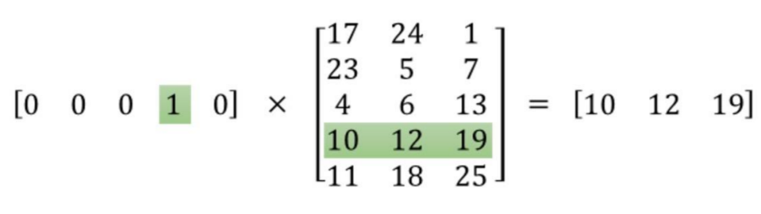

Word2vec model:
Word2Vec is a popular word embedding technique in natural language processing (NLP) developed by researchers at Google. It's designed to learn distributed representations of words in a continuous vector space from large amounts of unlabeled text data. The key idea behind Word2Vec is to train a neural network model to predict the context of a word based on its surrounding words in a sentence or document.

There are two main architectures for training Word2Vec models:

1. Continuous Bag of Words (CBOW): In this architecture, the model predicts the target word based on the context words surrounding it. The context words are used as input to the neural network, and the target word is predicted as the output. CBOW is generally faster to train and performs well on smaller datasets.

2. Skip-gram: In this architecture, the model predicts the context words given a target word. The target word is used as input to the neural network, and the context words are predicted as the outputs. Skip-gram is more effective for capturing semantic relationships between words and tends to perform better on larger datasets.

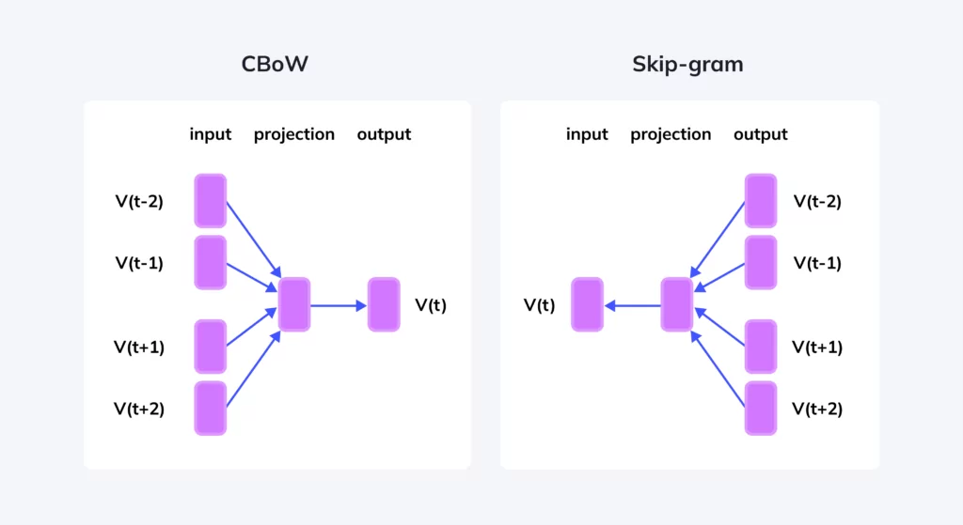

Once trained, Word2Vec models produce dense vector representations (embeddings) for each word in the vocabulary. Words with similar meanings or usage contexts are mapped to nearby points in the vector space. These embeddings can then be used to initialize neural network models for various NLP tasks or as features in machine learning algorithms.

Word2Vec has been widely adopted in both research and industry due to its simplicity, efficiency, and effectiveness in capturing semantic relationships between words. Pre-trained Word2Vec embeddings are also available for many languages and domains, making them a valuable resource for NLP practitioners.

Architecture of word2vec:
Word2Vec is simple neural network with single hidden layer.
It is note going to be used for the task it was trained on, instead we will take its hidden weight us them as our word embeddings.
Same architecture is used in auto encoder where it trains to compress the data in the hidden layer and decompress it back to the original at the output layer. In auto encoder is used to learn the good featuers.
In Word2Vec takes a single one hot vecotr compress it down to smaller dense vector and instead of decompressing it back to original vector. Input vector output the probabilities of the target word.

Problem of softmax in Word2Vec:
The softmax classification used in Word2Vec, particularly in the output layer, can pose some challenges, especially when dealing with large vocabularies. Here are some of the main issues associated with softmax classification in Word2Vec:

Computational Complexity: The softmax function computes a probability distribution over the entire vocabulary for each training sample, which can be computationally expensive, especially for large vocabularies. As the size of the vocabulary grows, the computation time and memory requirements for training the model increase significantly.

Memory Consumption: The softmax layer requires a large output layer with neurons equal to the size of the vocabulary. Storing and processing the weights associated with such a large output layer can consume a significant amount of memory, especially for models trained on large-scale datasets.

Difficulty in Handling Rare Words: The softmax function treats all words in the vocabulary equally during training, regardless of their frequency. As a result, rare words may receive less attention during training, leading to suboptimal representations for these words in the learned embeddings.

To address these challenges, various techniques have been proposed, including:

Hierarchical Softmax: This approach organizes the vocabulary into a binary tree structure, where each leaf node represents a word in the vocabulary. During training, instead of computing the softmax over the entire vocabulary, hierarchical softmax efficiently traverses the tree to approximate the probabilities of words, reducing the computational complexity.

Negative Sampling: Negative sampling is a simplified alternative to the full softmax function, where instead of predicting the probability distribution over all words in the vocabulary, the model is trained to distinguish the target word from randomly sampled negative words. This approach speeds up training and reduces memory consumption, particularly for large vocabularies.

Sequence-to-sequence (Seq2Seq):
Sequence-to-sequence (Seq2Seq) modeling is a type of neural network architecture used for tasks involving sequential data, where the input and output sequences can have different lengths. It's particularly popular in natural language processing (NLP) tasks such as machine translation, text summarization, and speech recognition. Here's a simplified explanation of how it works:

Encoder: The encoder processes the input sequence, typically through recurrent neural network (RNN) layers like Long Short-Term Memory (LSTM) or Gated Recurrent Unit (GRU). Each element of the input sequence is encoded into a fixed-length context vector, which represents the entire input sequence.

Context Vector: The context vector encapsulates the meaning of the input sequence. It's a condensed representation that captures the relevant information needed for generating the output sequence.

Decoder: The decoder takes the context vector produced by the encoder and generates the output sequence step by step. It's also usually implemented using RNNs like LSTM or GRU. At each step, the decoder produces the next element of the output sequence based on the context vector and the previously generated elements.

Training: During training, the model is trained to minimize the discrepancy between the predicted output sequence and the ground truth sequence. This is typically done using techniques like teacher forcing, where the decoder is fed the correct output sequence during training, rather than its own predictions.

Inference: During inference, the model generates the output sequence one element at a time based on the input sequence. At each step, the model's output from the previous step is fed as input to the current step until an end-of-sequence token is generated or a predefined maximum length is reached.

Greedy Search:
- Start with a random/special token to to begin the sequence.
- In greedy search, the token with the highest probability is selected as the next one.

Disadvantages of Greedy Search:
The main disadvantage of using greedy search for sequence modeling is that it tends to produce suboptimal results compared to other decoding strategies.

Limited Exploration: Greedy search only considers the most probable token at each step, leading to a lack of exploration in the search space. This can result in the model getting stuck in local optima and failing to find globally optimal solutions.
Ignoring Context: Greedy search does not take into account the context or dependencies between tokens in the sequence. It treats each token generation step independently, potentially leading to inconsistencies or incoherent sequences.

Beam Search:
Beam search is a popular decoding algorithm used in sequence modeling tasks, particularly in natural language processing (NLP) tasks like machine translation and text generation. It improves upon the limitations of greedy search by considering multiple candidate sequences simultaneously,

Initialization: Beam search starts with a beam width parameter, which determines the number of candidate sequences to consider at each step. Typically, this parameter is set to a small integer value, such as 3 or 5.

Initial Token: Similar to greedy search, beam search begins with a special token to indicate the start of the sequence.

Candidate Generation: At each decoding step, the model generates the next token for each candidate sequence in the beam. Instead of selecting only the token with the highest probability, beam search maintains the top-k candidates based on their probabilities.

Beam Expansion: After generating tokens for each candidate sequence, beam search expands the beam by considering all possible next tokens for each candidate. This results in multiple new candidate sequences.

Beam Pruning: To keep the search space manageable, beam search prunes the candidate sequences, retaining only the top-k sequences with the highest probabilities. This pruning helps prevent exponential growth in the number of candidate sequences as the decoding progresses.

Repeat: Steps 3-5 are repeated iteratively until the end-of-sequence token is generated for all candidate sequences or a maximum sequence length is reached.

Selection: Finally, beam search selects the candidate sequence with the highest probability among those that reach the end-of-sequence token as the output sequence.

Converting textual data into numerical representations, often referred to as text embedding or vectorization, is a fundamental task in natural language processing (NLP).

1.One-Hot Encoding:
Each word in the vocabulary is represented as a binary vector where all elements are zero except for the index corresponding to the word's position in the vocabulary, which is set to one.
- Advantages:
- Simple to understand and implement.
- Intuitive representation.
- Disadvantages:
- Results in high-dimensional, sparse vectors, which can be computationally inefficient and memory-intensive, especially for large vocabularies.
- Does not capture semantic relationships between words.

2.Bag-of-Words (BoW):
Each document is represented as a fixed-size vector where each element represents the frequency or presence of a word from the vocabulary.
- Advantages:
- Simplicity and efficiency in representation.
- Captures basic word frequency information.
- Disadvantages:
- Ignores word order and context, leading to loss of important information.
- Does not capture semantic similarity between words.

3.Term Frequency-Inverse Document Frequency (TF-IDF):
Similar to BoW, but each word's frequency is weighted by its inverse document frequency, which downweights common words and emphasizes rare words.
- Advantages:
- Helps mitigate the impact of common words while highlighting important terms.
- Provides better discrimination between documents compared to simple word frequency.
- Disadvantages:
- Still ignores word order and context.
- Sparse representation like one-hot encoding.

4.Word Embeddings (e.g., Word2Vec, GloVe, FastText):
Dense, low-dimensional vectors are learned for each word in a way that similar words have similar vectors, capturing semantic relationships.
- Advantages:
- Captures semantic similarity and relationships between words.
- Low-dimensional dense representations are more computationally efficient than sparse representations.
- Disadvantages:
- Requires large amounts of data for training.
- May struggle with out-of-vocabulary words if not properly handled.

5.Contextual Word Embeddings (e.g., ELMo, BERT):
Embeddings are generated dynamically based on the context of the word in the sentence or document, leveraging large pre-trained models.
- Advantages:
- Captures word meaning in context, allowing for more nuanced representations.
- State-of-the-art performance on various NLP tasks.
- Disadvantages:
- Computationally expensive due to large model sizes and complex architectures.
- Requires substantial computational resources for training and inference.

Each of these techniques has its own trade-offs in terms of simplicity, computational efficiency, and the ability to capture semantic information. The choice of technique often depends on the specific requirements of the NLP task at hand, including the size of the dataset, the complexity of the language patterns, and the available computational resources.

Self-attention:
self intention is a function that takes static embeddings as input and output the contextual embeddings.

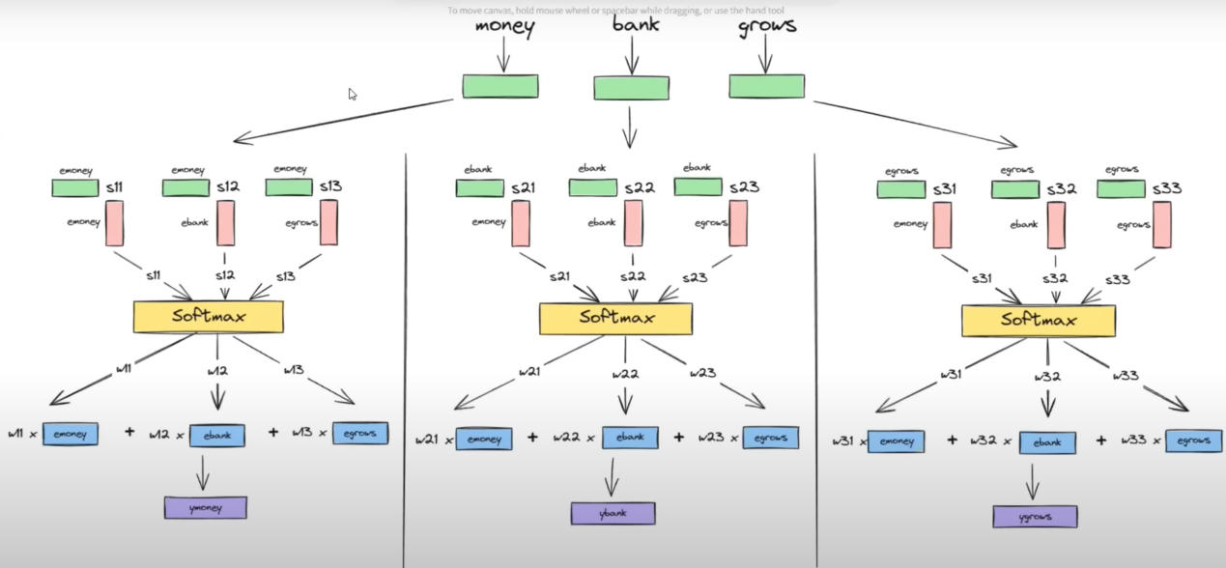

The above diagram shows that this process can run in parallel, which is good, and there are no parameters.

These embeddings are general contextual embeddings, not task-specific embeddings. For that purpose, we need to introduce weights and biases so that the model can learn the meaning of phrases like 'piece of cake' or 'break a leg' in a task-specific manner.

Example:
when processing the sentence "Apple makes great phones," the static embedding for "Apple" would indeed represent the fruit, which might not capture the intended meaning in this context.

However, with self-attention, the model can dynamically adjust the representation of "Apple" based on the surrounding words and the context of the sentence.

In this way, self-attention enables the model to adapt its understanding of words based on their context within the input sequence, allowing for more contextually relevant embeddings to be generated. This capability is particularly valuable in natural language understanding tasks where the meaning of words can vary depending on the context in which they are used.

Self Attention in Transformer:
Self Attention works by computing attention scores for each word in a sequence based on its relationship with every other word. These scores determine how much focus each word receives during processing, allowing the model to prioritize relevant information and capture complex dependencies across the sequence.

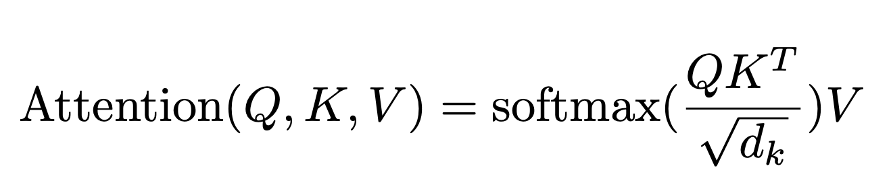

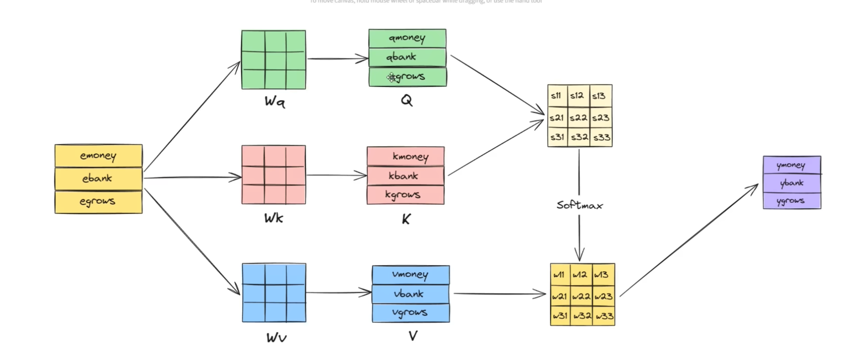

sqrt(d_k) in self_attention:
In self-attention mechanisms, particularly in the Transformer architecture, dividing the dot product of query and key vectors by the square root of their dimensionality (i.e., sqrt(d_k)) serves a couple of purposes:

- Normalization:
It helps to stabilize the gradients during training by scaling down the dot products. When the dimensionality of the vectors (d_k) is large, the dot products can become very large, which in turn can lead to very large gradients during backpropagation. Normalizing by sqrt(d_k) helps to keep the gradients at a reasonable scale, preventing them from becoming too small or too large.

Example:
If you have a random variable X with variance var(X), and you create another variable Y by scaling X by a constant c, then the variance of Y can be calculated as follows:
Given that

Y = cX
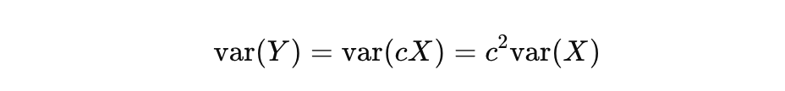
This is because when you scale a random variable by a constant c, the variance of the resulting variable is the square of c times the variance of the original variable. This is a fundamental property of variances.

- Attention Distribution:
It helps to ensure that the dot products don't grow too large in magnitude, which could result in overly sharp attention distributions. By scaling down the dot products, the softmax function applied afterwards results in more evenly distributed attention weights, allowing the model to attend to multiple parts of the input sequence more effectively.

Transformer model in detail:
let's delve into self-attention in the Transformer model in detail.

1. Key Concepts:
- Self-Attention Mechanism: Self-attention allows the model to weigh the importance of different words in a sequence when encoding or decoding it. It enables the model to focus on relevant parts of the input sequence, capturing dependencies and relationships between words effectively.

- Multi-Head Attention: To enhance the model's capacity to focus on different aspects of the input, Transformer employs multi-head attention. This mechanism computes attention multiple times in parallel, with different sets of learned parameters, allowing the model to attend to information from different representation subspaces.

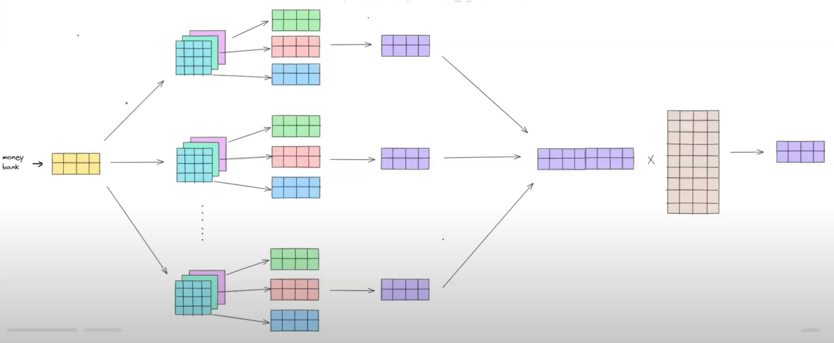

2. Architecture:
- Input Embeddings: The input sequence is first embedded into vectors. In the Transformer architecture, positional encodings are added to these embeddings to convey the position of each word in the sequence.
- Self-Attention Layers: Self-attention is applied in each layer of the Transformer. The input embeddings are processed through multi-head self-attention mechanisms, where queries, keys, and values are derived from the input embeddings.
- Attention Scores: For each word in the sequence, attention scores are computed with respect to all other words. These scores determine the importance of each word relative to others.
- Weighted Sum: The attention scores are used to compute a weighted sum of the values (output of the self-attention layer). This weighted sum represents the attended information for each word.
- Feed-Forward Neural Network: The weighted sum obtained from self-attention is passed through a feed-forward neural network layer, introducing non-linearity to the representations.
- Layer Normalization and Residual Connections: After each sub-layer (self-attention and feed-forward), layer normalization and residual connections are applied to stabilize and ease the training process.

3. Operations:
- Query, Key, and Value Calculations: For each word in the sequence, the query, key, and value vectors are computed from the input embeddings. These vectors are obtained through linear transformations of the input embeddings.
- Attention Scores Computation: Attention scores are calculated by taking the dot product between the query vector of one word and the key vector of another word, followed by scaling and applying a softmax function to obtain normalized attention weights.
- Weighted Sum: The attention scores are used to compute a weighted sum of the value vectors of all words in the sequence, producing the attended information for each word.
- Multi-Head Attention: Multi-head attention allows the model to jointly attend to information from different representation subspaces, enhancing its ability to capture different types of dependencies and relationships in the input.

4. Benefits:
- Captures Long-range Dependencies: Self-attention enables the model to capture long-range dependencies in the input sequence more effectively compared to traditional recurrent or convolutional architectures.
- Parallelization: Self-attention operations can be parallelized efficiently, making Transformer models faster to train and allowing for better scalability to longer sequences.
- Interpretability: The attention weights computed by self-attention provide insights into which parts of the input sequence are most relevant for each word's representation, enhancing model interpretability.

IMPORTANT:
Both self-attention computation and multi-head attention utilize the same computational resources in terms of memory and operations. In multi-head attention, the input is split into multiple heads, and each head computes its own set of attention scores and weighted sums independently. These individual outputs are then concatenated and linearly transformed to produce the final output.

Although multi-head attention involves additional operations to handle multiple heads, the total computational cost remains similar to that of a single self-attention operation. However, multi-head attention offers advantages such as increased model capacity and the ability to capture different types of relationships and dependencies in the input sequence by allowing the model to attend to information from different representation subspaces.

Therefore, while both self-attention computation and multi-head attention consume similar computational resources, multi-head attention enhances the model's expressive power and ability to capture complex patterns in the input data.

